0z

**Document History**

|  |  |  |  |
| --- | --- | --- | --- |
| Rev | Author | Date | Comment |
| 1.0 | Carl Wise | 2015-05-05 | JAWS 16.0 Run JAWS Settings |
| 1.1 | Carl Wise | 2017-12-19 | Adjust for JAWS 2018. |

# Summary

The JAWS 2018 Startup Wizard contains a page to configure JAWS Startup behavior on the logon screen and user desktop.

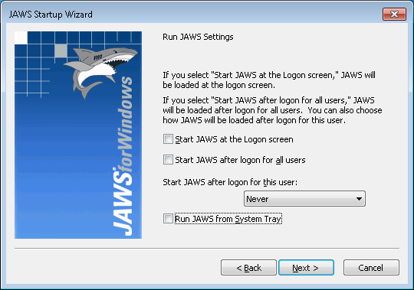

Some users have expressed an interest to configure this outside of the JAWS user interface. The following settings can be modified to configure the settings available in JAWS Startup Wizard Run JAWS Settings dialog:

# JAWS Version

Throughout this document, [*version*] is used. For JAWS 2018 and higher, [*version*] should be replaced with the product major.

Example: For JAWS 2018, set FreedomScientific_JAWS_v[*version*] to FreedomScientific_JAWS_v2018.

Prior to JAWS 2018, the version was formatted as file major.minor.

Example: For JAWS 17.0, set FreedomScientific_JAWS_v[*version*] to FreedomScientific_JAWS_v17.0.

# Start JAWS at the Logon Screen

Key = HKEY_LOCAL_MACHINE\SOFTWARE\Microsoft\Windows NT\CurrentVersion\Accessibility  
Configuration value

To enable, set Configuration value to FreedomScientific_JAWS_v[*version*]. To disable, delete this value.

# Start JAWS after logon for all users

Key = HKEY_LOCAL_MACHINE\Software\Freedom Scientific\JAWS\[*version*]  
Run Value

Set to 1 to enable, 0 to disable.

Key = HKEY_LOCAL_MACHINE\Software\Microsoft\Windows\CurrentVersion\Run  
JAWS Value

Set JAWS value to JAWS command line to launch JAWS: “C:\Program Files\Freedom Scientific\JAWS\[*version*]\jfw.exe” /run

# Start JAWS after logon for this user:

Key = HKEY_CURRENT_USER\Software\Freedom Scientific\JAWS  
Run Value

## Always

Set Value = 1

## Never

Set Value = 0

## Using the all users setting

Delete Value

# Run JAWS from the System Tray

In user settings default.jcf, set [Options]\ViewMode to 1 to run from System Tray. Set to 0 to run in full mode.